Company Confidential Application Form-Offshore RMG-TAG-V.4

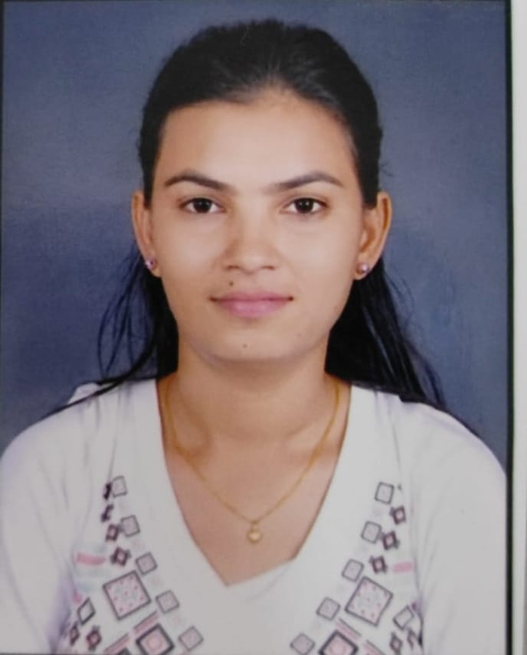

**Application for Employment**

**Personal Information**

**KAMINI KAILAS PATIL**

**Name (as per Aadhar Card): ____________________________________________________________________________**

**(First Name) (Middle Name) (Last Name)**

**Father’s (Full name): KAILAS MAHADU PATIL Mother’s (Full Name): MANISHA KAILAS PATIL**

**DOB (DD/MM/YYYY): _29/11/1998_ Place & State of Birth: _Ozar, Maharashtra Nationality: INDIAN**

**Male/Female/Transgender: __FEMALE_ Aadhar No: 884191892762__**

**Marital Status: single Married Separated,Widowed Spouse Name: ______________________________**

**PAN NO: _GAGPR3623N__ UAN Account NO: ___**

|  |  |  |  |
| --- | --- | --- | --- |
| **Source Details-** |  |  |  |

|  |  |  |  |  |  |  |  |  |
| --- | --- | --- | --- | --- | --- | --- | --- | --- |
| **Source  [Select Using ( √ )]** | Agency | Buddy | Direct | Portal | Advt | Reference | Contract / Sub Conversion | Others |
| **Name of Source  (Pls specify)** |  | Mayuri Rawandale  (1020841) |  |  |  |  |  |  |

**Passport Details**

|  |  |  |  |
| --- | --- | --- | --- |
| **Passport No** | **Place of Issue** | **Date of Issue (DD/MM/YY)** | **Date of Expiry (DD/MM/YY)** |
|  |  |  |  |

If you don’t have valid Passport and have applied for passport application: -

**Application No: ___________________________________ Date of Application: ________________________________**

**Present Address (PIN code Mandatory):**

**Pawar Nagar no 1 Thergon ,Pimpri Chinchwad,Maharashtra________________________________________________________________________________________________**

**__________________________________________________________________________PIN: _411033___**

**Landline: _______________________________________Mobile No: 9373297316**

**Email: kaminipatil4901@gmail.com**

**Permanent Address (PIN code Mandatory):**

**Vivekanad Nagar Balad Road Bhadgaon.**

**__________________________________________________________________________PIN: _424105_**

**Landline: _______________________________________Mobile No: 9373297316**

**Email: Primary___________________________________Secondary: ___________________________________________**

**Emergency Contact Detail:**

**Name: KAILAS MAHADU PATIL__Relationship: _FATHER______________________________________**

**Address: Vivekanad Nagar Balad Road Bhadgaon Tal: Bhadgaon Dist: Jalgaon**

**Landline: __________________________________________Mobile No:9518902644**

**Do you have any relative(s) working with any of the Mahindra Group companies including Tech Mahindra? YES NO**

**If yes Please give details below: -**

|  |  |  |  |  |
| --- | --- | --- | --- | --- |
| **Name of Relative/s** | **Relationship** | **Mahindra Gp Company** | **Emp ID** | **Department** |
|  |  |  |  |  |
|  |  |  |  |  |

**Signature of the Applicant: ___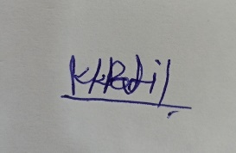___Date: ___25/05/2024_**

**Education Details:** **(Only those done through Govt recognized Institute/Universities)**

|  |  |  |  |  |  |  |  |  |
| --- | --- | --- | --- | --- | --- | --- | --- | --- |
| **Education** | **College/University** |  | **Name of Degree /Level** | **Duration (MM/YY)** | | | **Specialization** | **Percentage** |
| **(With Location)** |  | **from** |  | **To** |
| Matriculation/SSC/ Equivalent |  |  |  |  |  |  |  |  |
| STATE BOARD NASHIK |  | - | 2013 |  | 2014 |  | 79.80 % |
| Intermediate/HSC/ Equivalent | STATE BOARD NASHIK |  |  |  |  | 2016 |  | 58.92% |
|  |  |  | 2015 |  |  |  |  |
| Diploma/ Equivalent |  |  |  |  |  |  |  | 71.72: |
|  |  |  |  |  |  |  |  |
| Graduation/ Equivalent | NORTH MAHARASHTRA UNIVERSITY |  | BSc | 2019 |  | 2020 |  | 70.89 % |
|  |  |  |  |  |  | Computer Science |  |
| Post -Graduation/ Equivalent | NORTH MAHARASHTRA UNIVERSITY |  | MSc | 2020 |  | 2022 |  | 83.38 |
|  |  |  |  |  |  | Computer Science |  |

**Employment History:**

|  |  |
| --- | --- |
| **Present /Current Employment** | |
| **Name of the Employer** | **Industry Type:** |
| Address: | |
| Email and Phone No of Employer : |  |
| Period of Services : | Current Designation: |
| Start Date (DD/MM/YY): | Name of Reporting Manager: |
| End Date (DD/MM/YY): | Designation of Reporting Manager: |
| Current CTC: | Current Monthly In hand: |
| Variable/Incentive If any: | Variable Payout frequency : |

**Previous Employment/ Jobs:**

|  |  |  |  |  |  |  |  |  |  |
| --- | --- | --- | --- | --- | --- | --- | --- | --- | --- |
| **Sr No** | **Name and Address of Employer** | | | **Emp Id (Must fill)** | **Period (DD/MM/YYYY)** | | | **Designation** | **Last Salary Drawn** |
| **(Please also give Telephone Nos.)** | | | **From** | | **To** | **(Per Annum)** |
| 1 |  | | |  |  |  |  |  |  |
| 2 |  |  |  |  |  |  |  |  |  |
| 3 |  |  |  |  |  |  |  |  |  |
| 4 |  |  |  |  |  |  |  |  |  |
| 5 |  |  |  |  |  |  |  |  |  |
| 6 |  |  |  |  |  |  |  |  |  |
| 7 |  |  |  |  |  |  |  |  |  |
| 8 |  |  |  |  |  |  |  |  |  |

**Signature of the Applicant: _____ __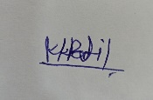________________ Date: _______25/05/2024________________________**

**Gap Details- Gap Reasons in Education & Employments:**

**(Need to cover gaps of more than 1 month in employments & education)**

|  |  |  |  |
| --- | --- | --- | --- |
| **Sr No** | **Period (MM/YYYY)** | | **Reason** |
| **From** | **To** |
| **1** | **2023** | **2024** | **Educational gap due to financial problem** |
| **2** |  |  |  |
| **3** |  |  |  |
| **4** |  |  |  |
| **5** |  |  |  |

**Professional References :( Please provide detail of three professional references who are known to you)**

|  |  |  |  |
| --- | --- | --- | --- |
| **Details** | **Reference No 1** | **Reference No 2** | **Reference No 3** |
| **Full Name -** | **MAYURI VISHRAM RAVANDALE** | **ARCHANA DEVAJI PATIL** | **MAYUR SANJAY DESHMUKH** |
| **Designation** | **ASSOCIATE CUSTOMER SUPPORT** | **QUALITY ANALYST** | **SENIOR ANALYST** |
| **Email ID** | **Mayuriranvandale25r.com** | **Patilarchana1239@gmail.com** | **Deshmukhmayur8421@gmail.com** |
| **Contact No** | **9168560718** | **9767852327** | **8421256924** |
| **Nature Of Association** | **Tech Mahindra** | **ADA tech Solution** | **CAPGEMINI** |

**General:**

**Have you ever joined / worked in any of the Tech Mahindra BPS or its entities before? YES NO**

**(if yes, pls share the details of above / with your HR)**

**Have you ever applied for a job with any of the Mahindra Group Cos. in the last 6 months? YES NO**

**If yes, give details:**

|  |  |  |  |
| --- | --- | --- | --- |
| **Name of Company** | **Position Applied For** | **Date of Application** | **Reason for Not Joining** |
|  |  |  |  |
|  |  |  |  |

**Any additional information you feel relevant to your candidature:**

**________________________________________________________________________________________________________________________________________________________________________________________________**

|  |
| --- |
| **Expected CTC :** |
| **Joining Time required :** |

|  |  |  |  |  |  |  |  |  |
| --- | --- | --- | --- | --- | --- | --- | --- | --- |
| **I certify that:** |  |  |  |  |  |  |  |  |
| **1.The information furnished above is factually correct and subject to verification by Tech Mahindra Ltd. I authorize Tech M Ltd to access my Resume and Statutory documents for interview purpose & Hiring at Tech M BPS.** | | | | | | | |  |
| **2. All my education qualifications have been acquired from institutes duly recognized by Govt. established statutory authorities.** | | | | | | | | |
| **3. I accept that an appointment given to me can be revoked; if any of above, information has been misstated or unstated.** | | | | | | | | |

**Signature of the Applicant: _____** **____Date: ___25/05/2024__**

**General Declaration**

**Have you ever discharged, dismissed or terminated from your previous employment? YES NO**

If yes, kindly furnish details **________________________________________________________________________ ________________________________________________________________________________________________**

**Are you willing to work in shift timings as suggested by Management? YES NO**

**Have you signed an employment bond with previous employer (s)? YES NO**

If yes, kindly furnish details **________________________________________________________________________ ________________________________________________________________________________________________**

**Are you suffering from any handicap/s, ailments or are you under long-term medication? YES NO**

If yes, kindly furnish details **________________________________________________________________________ ________________________________________________________________________________________________**

**Are you under any service agreement or Bond? YES NO**

If yes, kindly furnish details **________________________________________________________________________ ________________________________________________________________________________________________**

**Do you have history of drug, alcohol abuse, depression, and /or any other psychological disorder? YES NO**

If yes, kindly furnish details **________________________________________________________________________ ________________________________________________________________________________________________**

**Have you ever been convicted by any court of law on grounds including civil, criminal, and socio-economic or cybercrimes or other acts punishable under the Information Technology Act? YES NO**

If yes, kindly furnish details **________________________________________________________________________ ________________________________________________________________________________________________**

**Please detail out if any Court order has been passed by the Court**

**________________________________________________________________________________________________**

**________________________________________________________________________________________________**

|  |  |  |  |  |  |  |  |  |
| --- | --- | --- | --- | --- | --- | --- | --- | --- |
| **I certify that** |  |  |  |  |  |  |  |  |
| **The information furnished above is factually correct and subject to verification by Tech Mahindra Ltd.** | | | | | | | |  |

**Signature of the Applicant: ____****____Date: _25/05/2024__**

**Background Verification (BV) Undertaking**

* I’m fully aware that Tech Mahindra conducts **Background Verification through external Agency.**
* The information I have shared is subject to **strict validation and verification**, conducted by professional background Agencies.
* I have been made aware that the following are covered in my background verification
  + **Last 2 employments** (Including present employment) or all employment in the last 3 years.
    - Duration
    - Designation
    - Salary
    - Highest Education
* I’m aware I need to share **correct/factual information** during my candidature with Tech Mahindra.
* Documents required for background verification provided by me **are true copies of originals**.
* I have understood that a background verification coded **RED** would lead to
  + **Termination of the job without any prior notice.**
  + **Blacklisting of Individual Candidature.**
  + **Recovery of liquidated Damages of INR 30,000/- from me (I Acknowledge that this is a conservative estimate of Genuine cost incurred by the company towards my recruitment, training etc.)**
  + **Institution of Criminal and Civil Action against me for any wrongful act of mine.**

I hereby confirm and declare that all the information I have shared is true and correct and in case of any variation/deviation then I’m liable face to above mentioned consequence.

Signature of Candidate: 

Name of Candidate: KAMINI KAILAS PATIL

Date: …25/05/2024.

Location: PUNE

**Candidate Undertaking**

* I have been explained the salary structure and the salary offered to me, is as discussed and agreed by me.
* I agree and have given consent to the **Training and Background Verification Undertaking.**
* I am willing to work in shifts (24*7) including **night shifts**.
* I agree to work, on an average of 5 or 6 days in a week, depending on the Project schedule for 9.5 hours shift if 5 days working per week or 9 hour shift schedule if the process is operating with 6 days per week working model. Week off can be split / rotational.
* I understand that during the training period I will **NOT** be paid the **Performance Incentive** if applicable in the salary annexure.
* **Performance Incentive will be paid from** **GO LIVE** **date** **ONLY**.
* **Performance Incentive** is based on monthly performance as applicable.
* **Door to door pickup & drop will be given only during Odd Hours. (Starts/Ends after 10 PM).** A nominal charge up to 1000/- (For both sides) will be deducted (in case of usage of company transport).
* The company transport is on shared basis, employees from other processes may also be required to share the same transport.
* I understand that Tech M **does not deal with any consultant** for BPS hiring and I have not paid any money to anyone for employment with Tech M.
* I have understood the hiring zone policy and I reside within the transport boundary or I am willing to relocate if the present address is out of hiring zone.
* No Nodal Pick up or Drop facility for Female associate if not in hiring zone.
* I Confirm the details provided above is true from the best of my knowledge and authentic and I have all the supporting document. Company has right to take legitimate action in case of any fraudulent information found related to any document or interview.
* I hereby declare that I am not enrolled into any full time or part time regular course and would not require leave for any exam which would affect my Job at Tech Mahindra Ltd.
* I will adhere to the applicable onboarding / Induction / Training / Office working hours Schedule and will comply with the same.

I have read all the above points carefully, accept the same and do not have any objection in working under above said terms and conditions.

Signature of Candidate: ……

Name of Candidate: KAMINI KAILAS PATIL

Date: 25/05/2024.

Location: …PUNE

**CONFIDENTIALITY AGREEMENT**

I, Mr./Ms.__KAMINI KAILAS PATIL__ would like to state the following:

1. I understand that Tech Mahindra Ltd will conduct an evaluation for my selection process at Tech Mahindra Ltd.
2. I understand that any software, documentation or any other material that I produce during the course of the evaluation is legal property of Tech Mahindra Ltd/Tech Mahindra Ltd's Customer and I shall not have any claims or rights towards the same.
3. I understand that during the course of the evaluation I should not use any software, systems, ideas, concept, designs, documentation or any other material, belonging to any individual or body corporate, without a prior permission from such individual or body corporate. I will also keep Tech Mahindra Ltd informed, prior to such usage.
4. I understand that during the course of evaluation, I should, at all times, observe secrecy in respect of any technical, trade or business data, customers' names/business details or any other information that might come to my knowledge or pos­session, which according to the Company, are necessarily confidential and form valuable property of the Company. I shall not disclose nor cause the disclosure of any such data in any manner whatsoever.
5. I also understand that I am prohibited from using any information, specifically identified by Tech Mahindra Limited as confidential or may be reasonably construed as Confidential, for purposes other than the purpose for which it is disseminated. Also, I am prohibited from reproducing or disclosing such Confidential Information to any third party without the written permission of Tech Mahindra Ltd except for carrying out the purpose for which the information is disseminated.
6. On completion/cession of my evaluation, I shall return to Tech Mahindra Ltd all tangible forms of the Confidential Information provided by Tech Mahindra Ltd, including any copies made by me and shall not thereafter use or disclose the Confidential Information provided by Tech Mahindra Ltd.

7. I understand the consequences of violating the requirements of clauses mentioned hereinabove, which may extend up to Tech Mahindra Ltd taking suitable disciplinary and/or legal action against me in accordance with the laws of India.

Signature of Candidate: ……

Name of Candidate: KAMINI KAILAS PATIL

Date: 25/05/2024.

Location: ……PUNE

**CODE OF CONDUCT**

I, Mr./Ms KAMINI KAILAS PATIL residing at THERGAON PUNE____ hereby agree to complete the evaluation provided by Tech Mahindra in accordance with the requirements provided herein. I understand that Tech Mahindra reserves the right to update and modify the requirements contained herein from time to time, and such a changed requirements shall apply to me with the same force and effect as the original requirements.

**Code of Conduct**

* The Trainee working must be able to understand written and spoken English well enough to comprehend basic emergency warnings such as; stop, keep out, Fire Exit, Restricted, etc
* The badge provided by Tech Mahindra shall be prominently display on the exterior clothing while being in the premises of Tech Mahindra.
* The Trainee may limit his enter to only those areas, locations and doors to which he is authorized.
* The Trainee shall not use or authorize to use any information asset and other equipments without the authorization from the designated owner of the equipment. Additionally, if authorized, its use should be in accordance with the requirements and recommendations of the designated owner.
* Flammable liquids, gases and materials will not be allowed on Tech Mahindra property without prior authorization of Tech Mahindra.
* The Trainee shall immediately report to the Tech Mahindra Trainee to whom he administratively reports any incident of fire, theft, sabotage, environmental incidents (including spills), injury, suspicious behavior, etc. discovered by him.
* The Trainee shall not carry out unauthorized use, removal, destruction, or defacing of Tech Mahindra resources or property.
* No photography or any sound or video recordings shall be done at Tech Mahindra’s Site without the written consent of Tech Mahindra.
* The Trainee shall not disclose or discuss with any third party or unauthorized person, matters relating to Tech Mahindra (e.g. Information on premises, discussions, people, etc.) which they might come across during their evaluation period with Tech Mahindra.
* The Trainee must comply with all applicable laws and regulations while being on the premises of Tech Mahindra.

I acknowledge my understanding of the above requirements and undertake to comply with it. Further, I understand the consequences of violating the requirements of clauses mentioned herein which may extend to Tech Mahindra taking suitable disciplinary and/or legal action.

Signature of Candidate: …

Name of Candidate: KAMINI KAILAS PATIL

Date: …25/05/2024.

Location: …PUNE